Dordon Primary School

Online Safety Policy

Written by: | J Price | Date: March 2023
Date for review: | March 2024
Approved by governors: | 27th March 2023

Dordon Primary School
Online Safety Policy

Aims

Our school aims to:
- Have robust processes in place to ensure the online safety of pupils, staff, volunteers and governors
- Deliver an effective approach to online safety, which empowers us to protect and educate the whole school community in its use of technology
- Establish clear mechanisms to identify, intervene and escalate an incident, where appropriate

The 4 key categories of risk
Our approach to online safety is based on addressing the following categories of risk:
- Content – being exposed to illegal, inappropriate or harmful content, such as pornography, fake news, racism, misogyny, self-harm, suicide, antisemitism, radicalisation and extremism
- Contact – being subjected to harmful online interaction with other users, such as peer-to-peer pressure, commercial advertising and adults posing as children or young adults with the intention to groom or exploit them for sexual, criminal, financial or other purposes
- Conduct – personal online behaviour that increases the likelihood of, or causes, harm, such as making, sending and receiving explicit images (e.g. consensual and non-consensual sharing of nudes and semi-nudes and/or pornography), sharing other explicit images and online bullying; and
- Commerce – risks such as online gambling, inappropriate advertising, phishing and/or financial scams

Legislation and guidance
This policy is based on the Department for Education’s (DfE) statutory safeguarding guidance, Keeping Children Safe in Education, and its advice for schools on:
- Teaching online safety in schools
- Preventing and tackling bullying and cyber-bullying: advice for headteachers and school staff
- Searching, screening and confiscation
It also refers to the DfE’s guidance on protecting children from radicalisation.
It reflects existing legislation, including but not limited to the Education Act 1996 (as amended), the Education and Inspections Act 2006 and the Equality Act 2010.
In addition, it reflects the Education Act 2011, which has given teachers stronger powers to tackle cyber-bullying by, if necessary, searching for and deleting inappropriate images or files on pupils’ electronic devices where they believe there is a ‘good reason’ to do so.
The policy also takes into account the National Curriculum computing programmes of study.

Roles and responsibilities
The School Standards Committee (SSC)
The SSC has overall responsibility for monitoring this policy and holding the Executive Headteacher to account for its implementation.
The SSC will co-ordinate regular meetings with appropriate staff to discuss online safety, and monitor online safety logs as provided by the designated safeguarding lead (DSL).
The governor who oversees online safety is T Turnbull.
All governors will:
- Ensure that they have read and understand this policy
- Agree and adhere to the terms on acceptable use of the school’s ICT systems and the internet
- Ensure that online safety is a running and interrelated theme while devising and implementing their whole school or college approach to safeguarding and related policies and/or procedures
- Ensure that, where necessary, teaching about safeguarding, including online safety, is adapted for vulnerable children, victims of abuse and some pupils with special educational needs and/or disabilities (SEND). This is because of the importance of recognising that a ‘one size fits all’ approach may not be appropriate for all children in all situations, and a more personalised or contextualised approach may often be more suitable

The Executive Headteacher
The Executive Headteacher is responsible for ensuring that staff understand this policy, and that it is being implemented consistently throughout the school.
The designated safeguarding lead (DSL)
Details of the school’s DSL and deputies are set out in our child protection and safeguarding policy as well as relevant job descriptions.
The DSL takes lead responsibility for online safety in school, in particular:
- Supporting the Executive Headteacher in ensuring that staff understand this policy and that it is being implemented consistently throughout the school
- Working with the Executive Headteacher, ICT technical support and other staff, as necessary, to address any online safety issues or incidents
- Managing all online safety issues and incidents in line with the school child protection policy
- Ensuring that any online safety incidents are logged (see appendix 2) and dealt with appropriately in line with this policy
- Ensuring that any incidents of cyber-bullying are logged and dealt with appropriately in line with the school relational policy
- Updating and delivering staff training on online safety (appendix 1 contains a self-audit for staff on online safety training needs)
- Liaising with other agencies and/or external services if necessary
- Providing regular reports on online safety in school to the Executive Headteacher and/or governing board
This list is not intended to be exhaustive.
Technical Support Provider
The Local Authority technical support provider is responsible for:
- Putting in place an appropriate level of security protection procedures, such as filtering and monitoring systems, which are reviewed and updated on a regular basis to assess effectiveness and ensure pupils are kept safe from potentially harmful and inappropriate content and contact online while at school, including terrorist and extremist material
- Ensuring that the school’s ICT systems are secure and protected against viruses and malware, and that such safety mechanisms are updated regularly
- Conducting a full security check and monitoring the school’s ICT systems on a weekly basis
- Blocking access to potentially dangerous sites and, where possible, preventing the downloading of potentially dangerous files
This list is not intended to be exhaustive.
All staff and volunteers
All staff, including contractors and agency staff, and volunteers are responsible for:
- Ensuring that any online safety incidents are logged (see appendix 2) and dealt with appropriately in line with this policy
- Ensuring that any incidents of cyber-bullying are dealt with appropriately in line with the school relational policy
- Maintaining an understanding of this policy
- Implementing this policy consistently
- Agreeing and adhering to the terms on acceptable use of the school’s ICT systems and the internet and ensuring that pupils follow the school’s terms on acceptable use.
- Working with the DSL to ensure that any online safety incidents are logged (see appendix 2) and dealt with appropriately in line with this policy
- Ensuring that any incidents of cyber-bullying are dealt with appropriately in line with the school relational policy
- Responding appropriately to all reports and concerns about sexual violence and/or harassment, both online and offline and maintaining an attitude of ‘it could happen here’

This list is not intended to be exhaustive.
Parents
Parents are expected to:
- Notify a member of staff or the Executive Headteacher of any concerns or queries regarding this policy
- Ensure their child has read, understood and agreed to the terms on acceptable use of the school’s ICT systems and internet (appendices 1 and 2)
Parents can seek further guidance on keeping children safe online from the following organisations and websites:
- What are the issues? - UK Safer Internet Centre
- Hot topics - Childnet International
- Parent factsheet - Childnet International
- Healthy relationships – Disrespect Nobody
Visitors and members of the community
Visitors and members of the community who use the school’s ICT systems or internet will be made aware of this policy, when relevant, and expected to read and follow it. If appropriate, they will be expected to agree to the terms on acceptable use.

Educating pupils about online safety
Pupils will be taught about online safety as part of the curriculum:
All schools have to teach:
- Relationships education and health education in primary schools

In Key Stage 1, pupils will be taught to:
- Use technology safely and respectfully, keeping personal information private
- Identify where to go for help and support when they have concerns about content or contact on the internet or other online technologies

Pupils in Key Stage 2 will be taught to:
- Use technology safely, respectfully and responsibly
- Recognise acceptable and unacceptable behaviour
- Identify a range of ways to report concerns about content and contact

By the end of primary school, pupils will know:
- That people sometimes behave differently online, including by pretending to be someone they are not
- That the same principles apply to online relationships as to face-to-face relationships, including the importance of respect for others online including when we are anonymous
- The rules and principles for keeping safe online, how to recognise risks, harmful content and contact, and how to report them
- How to critically consider their online friendships and sources of information including awareness of the risks associated with people they have never met
- How information and data is shared and used online
- How to respond safely and appropriately to adults they may encounter (in all contexts, including online) whom they do not know
The safe use of social media and the internet will also be covered in other subjects where relevant.
Where necessary, teaching about safeguarding, including online safety, will be adapted for vulnerable children, victims of abuse and some pupils with SEND

Educating parents about online safety
The school will raise parents’ awareness of internet safety in letters or other communications home, and in information via our website. This policy will also be shared with parents.
Online safety will also be covered during parents’ evenings.
If parents have any queries or concerns in relation to online safety, these should be raised in the first instance with the Executive Headteacher and/or the DSL.
Concerns or queries about this policy can be raised with any member of staff or the Executive Headteacher.

Cyber-bullying
Definition
Cyber-bullying takes place online, such as through social networking sites, messaging apps or gaming sites. Like other forms of bullying, it is the repetitive, intentional harming of one person or group by another person or group, where the relationship involves an imbalance of power. (See also the school relational policy.)
Preventing and addressing cyber-bullying
To help prevent cyber-bullying, we will ensure that pupils understand what it is and what to do if they become aware of it happening to them or others. We will ensure that pupils know how they can report any incidents and are encouraged to do so, including where they are a witness rather than the victim.
The school will actively discuss cyber-bullying with pupils, explaining the reasons why it occurs, the forms it may take and what the consequences can be. Class teachers will discuss cyber-bullying with their class.
Teaching staff are also encouraged to find opportunities to use aspects of the curriculum to cover cyber-bullying. This includes relationships, social, health and economic (RSHE) education, and other subjects where appropriate.
All staff, governors and volunteers (where appropriate) receive training on cyber-bullying, its impact and ways to support pupils, as part of safeguarding training (see section 11 for more detail).
In relation to a specific incident of cyber-bullying, the school will follow the processes set out in the school relational policy. Where illegal, inappropriate or harmful material has been spread among pupils, the school will use all reasonable endeavours to ensure the incident is contained.
The DSL will consider whether the incident should be reported to the police if it involves illegal material, and will work with external services if it is deemed necessary to do so.

Examining electronic devices
The Executive Headteacher, and any member of staff authorised to do so by the Executive Headteacher can carry out a search and confiscate any electronic device that they have reasonable grounds for suspecting:
- Poses a risk to staff or pupils, and/or
- Is identified in the school rules as a banned item for which a search can be carried out, and/or
- Is evidence in relation to an offence
Before a search, if the authorised staff member is satisfied that they have reasonable grounds for suspecting any of the above, they will also:
- Make an assessment of how urgent the search is, and consider the risk to other pupils and staff. If the search is not urgent, they will seek advice from the Executive Headteacher.
- Explain to the pupil why they are being searched, how the search will happen, and give them the opportunity to ask questions about it
- Seek the pupil’s cooperation
Authorised staff members may examine, and in exceptional circumstances erase, any data or files on an electronic device that they have confiscated where they believe there is a ‘good reason’ to do so.
When deciding whether there is a ‘good reason’ to examine data or files on an electronic device, the staff member should reasonably suspect that the device has, or could be used to:
- Cause harm, and/or
- Undermine the safe environment of the school or disrupt teaching, and/or
Commit an offence
If inappropriate material is found on the device, it is up to the staff member in conjunction with the DSL or Executive Headteacher to decide on a suitable response. If there are images, data or files on the device that staff reasonably suspect are likely to put a person at risk, they will first consider the appropriate safeguarding response.
When deciding if there is a good reason to erase data or files from a device, staff members will consider if the material may constitute evidence relating to a suspected offence. In these instances, they will not delete the material, and the device will be handed to the police as soon as reasonably practicable. If the material is not suspected to be evidence in relation to an offence, staff members may delete it if:
- They reasonably suspect that its continued existence is likely to cause harm to any person, and/or
- The pupil and/or the parent refuses to delete the material themselves
If a staff member suspects a device may contain an indecent image of a child (also known as a nude or semi-nude image), they will:
- Not view the image
- Confiscate the device and report the incident to the DSL (or equivalent) immediately, who will decide what to do next. The DSL will make the decision in line with the DfE’s latest guidance on screening, searching and confiscation and the UK Council for Internet Safety (UKCIS) guidance on sharing nudes and semi-nudes: advice for education settings working with children and young people
Any searching of pupils will be carried out in line with:
- The DfE’s latest guidance on searching, screening and confiscation
- UKCIS guidance on sharing nudes and semi-nudes: advice for education settings working with children and young people
- Our relational policy
Any complaints about searching for or deleting inappropriate images or files on pupils’ electronic devices will be dealt with through the school complaints procedure.

Acceptable use of the internet in school
All pupils, parents, staff, volunteers and governors are expected to sign an agreement regarding the acceptable use of the school’s ICT systems and the internet (appendices 1-3). Visitors will be expected to read and agree to the school’s terms on acceptable use if relevant.
Use of the school’s internet must be for educational purposes only, or for the purpose of fulfilling the duties of an individual’s role.
We will monitor the websites visited by pupils, staff, volunteers, governors and visitors (where relevant) to ensure they comply with the above.
More information is outlined in the Acceptable Use policy.

Pupils using mobile devices in school
Pupils may bring mobile devices into school where it is necessary for their safety e.g. for children walking home alone, but are not permitted to use them during:
- Lessons
- Clubs before or after school, or any other activities organised by the school.
Mobile phones must be handed in to the main office at the start of the school day where they will be stored safely until the child collects it at the end of their day.
Any breach of the acceptable use agreement by a pupil may trigger disciplinary action in line with the school relational policy, which may result in the confiscation of their device.

Staff using work devices outside school
All staff members will take appropriate steps to ensure their devices remain secure. This includes, but is not limited to:
- Keeping the device password-protected – strong passwords are at least 8 characters, with a combination of upper and lower-case letters, numbers and special characters (e.g. asterisk or currency symbol)
- Ensuring their hard drive is encrypted – this means if the device is lost or stolen, no one can access the files stored on the hard drive by attaching it to a new device
- Making sure the device locks if left inactive for a period of time
- Not sharing the device among family or friends
- Keeping operating systems up to date – always install the latest updates
Staff members must not use the device in any way which would violate the school’s terms of acceptable use.
Work devices must be used solely for work activities.
If staff have any concerns over the security of their device, they must seek advice from Julie Price (Computing Lead) or Trevor Price (Technical Support)
More information about staff use of devices- both school owned and personal- can be found in the Staff Code of Conduct.

How the school will respond to issues of misuse
Where a pupil misuses the school’s ICT systems or internet, we will follow the procedures set out in our relational policy and acceptable use policy. The action taken will depend on the individual circumstances, nature and seriousness of the specific incident, and will be proportionate.
Where a staff member misuses the school’s ICT systems or the internet, or misuses a personal device where the action constitutes misconduct, the matter will be dealt with in accordance with the staff code of conduct. The action taken will depend on the individual circumstances, nature and seriousness of the specific incident.
The school will consider whether incidents which involve illegal activity or content, or otherwise serious incidents, should be reported to the police.

Training
All new staff members will receive training, as part of their induction, on safe internet use and online safeguarding issues including cyber-bullying and the risks of online radicalisation.
All staff members will receive refresher training at least once each academic year as part of safeguarding training, as well as relevant updates as required (for example through emails, e-bulletins and staff meetings).
The DSL and deputies will undertake child protection and safeguarding training, which will include online safety, at least every 2 years. They will also update their knowledge and skills on the subject of online safety at regular intervals, and at least annually.
Governors will receive training on safe internet use and online safeguarding issues as part of their safeguarding training.
Volunteers will receive appropriate training and updates, if applicable.
More information about safeguarding training is set out in our child protection and safeguarding policy.

Monitoring arrangements
The DSL logs behaviour and safeguarding issues related to online safety on CPOMS. An example of the reporting form can be found in appendix 2.
This policy will be reviewed every year by the Computing lead. At every review, the policy will be shared with the School Standards Committee.

Links with other policies
This online safety policy is linked to our:
- Child protection and safeguarding policy
- Anti-bullying
- Relational policy (behaviour)
- Staff Code of Conduct
- Data protection policy and privacy notices
- Complaints procedure
- ICT acceptable use policy
- Social media policy

Appendix 1: online safety training needs – self audit for staff

online safety training needs audit
Name of staff member/volunteer: | Date:
Question | Yes/No (add comments if necessary)
Do you know the name of the person who has lead responsibility for online safety in school?
Do you know what you must do if a pupil approaches you with a concern or issue?
Are you familiar with the school’s acceptable use agreement for staff, volunteers, governors and visitors?
Are you familiar with the school’s acceptable use agreement for pupils and parents?
Do you regularly change your password for accessing the school’s ICT systems?
Are you familiar with the school’s approach to tackling cyber-bullying?
Are there any areas of online safety in which you would like training/further training?

Appendix 2: online safety incident log
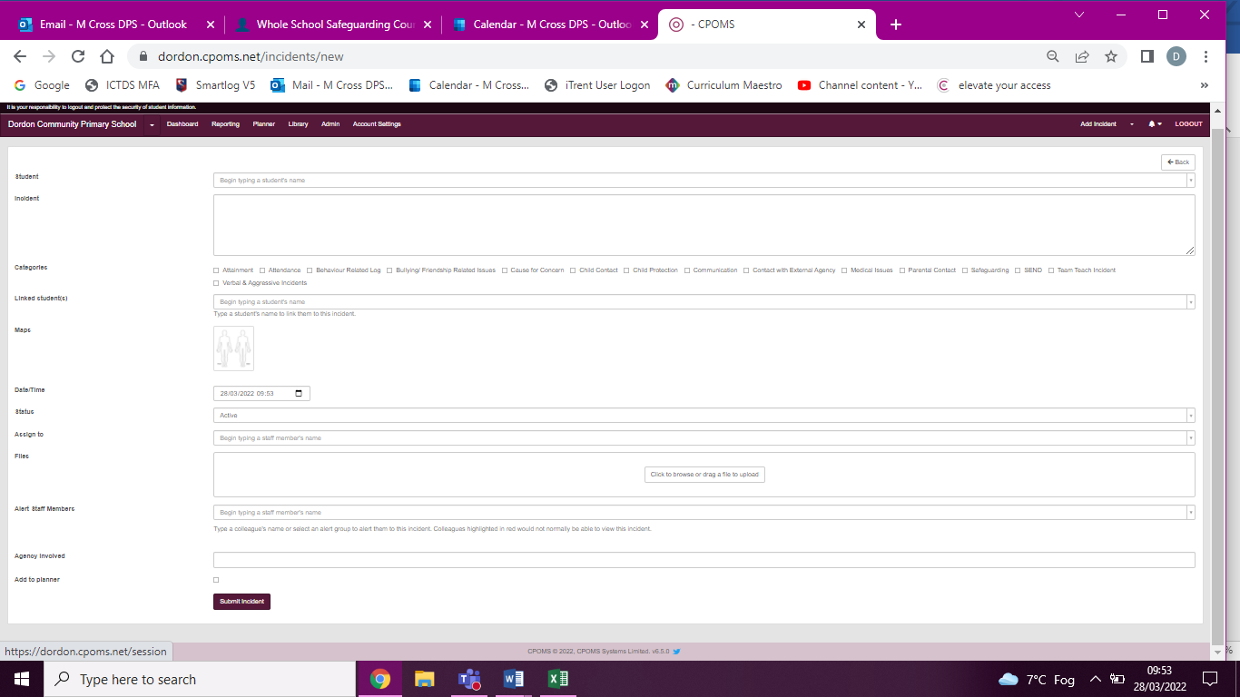
Using CPOMS – online system.

