Dordon Primary School


Relational Policy
Policy Owner | Moira Cross
Version | 1
Approved Date | 17.3.26
Approving Body | School Standards Committee
Next Review Date | March 2027

 | Last Modified | Last Modified By | Document Changes

Dordon Primary School
Relational Policy
At Dordon Primary School we hold positive relationships between all stakeholders at the heart of our practice. We work hard to establish and maintain positive relationships. We recognise and embrace the importance of repairing and restoring these relationships following any incident in school where damage may have been incurred.
It is important to recognise that behaviour is often an expression of a need not being met or a person not getting what they want. We will always seek to explore the cause behind a behaviour rather than focus on the behaviour itself.

This policy aims to:
- Identify how our school establishes positive relationships
- Outline the process to be followed where relationships may have been damaged
- Recognise the importance of de-escalation and prevention in maintaining relationships
- Identify the importance of involving all parties in maintaining relationships – including the children

Ethos
Children in our school are individuals. They are always treated as such. We foster high expectations of all children's behaviour, work and relationships and to celebrate success widely. We build children's self-discipline, and a sense of pride and respect for themselves, their work, peers, school and the wider community. We develop positive relationships between school, parents and our community and a shared understanding of our aims. We create a school environment where children are healthy, happy, safe and secure, where they feel valued and respected within a diverse and inclusive environment.
The building of positive relationships is a fundamental component of life in our school. The building of these relationships is important for all children but it is essential for children who have experienced trauma or Adverse Childhood Experiences or have additional needs – for example children with attachment issues. For these children, positive relationships provide a sense of safety, security and belonging.
Expectations
The one word school rule at Dordon is RESPECT. This means pupils within school are expected to:
- Respect themselves
- Respect each other
- Respect all adults
- Respect the school environment
See Appendix A for behaviours that do not meet these expectations.

Fostering positive relationships
This is an ongoing process and can be thought of as a system of deposits in a bank. Shared positive experiences form the grounding of any relationship. These do not have to be significant events but small, positive, frequent interactions. This provides common ground and fosters a sense of a shared experience.
Examples of these interactions include:
- Greet at classroom door
- Awarding GEMS as recognition of meeting expectations
- Praise and reward (See Appendix B)
- Pay attention
- Laugh with them
- End lessons on a good note
- Learn to apologise
- Develop and cultivate compassion
- High five at the classroom door (or a smile instead)
- Look out for their team’s results
- Play games on the playground
- Give consistently but receive occasionally
- Brag about them outrageously to others
Research suggests that for every negative experience children will need at least 7 positive experiences in order to maintain the relationship. It is our aim to exceed this through frequent interactions with all children so there are reserves to draw upon from their emotional bank.

Zones of regulation
The pupils are taught and understand the Zones of Regulation – these are 4 colour zones that reflect their feelings. It is important that pupils can name their feelings and can use strategies to deal with them.
The Zones of Regulation are displayed in every classroom and the children are encouraged to place themselves in the zone they are feeling at different points in the day. If pupils identify themselves as red or blue then adults intervene quickly to support regulation.
(See Appendix C for the Zones)

Stop It Please
A strategy that is taught in every class and encouraged is the use of the phrase ‘Stop It Please’. This is to support children in the management of low level behaviours.
If a child is finding the behaviour of another person unacceptable, then before telling a teacher, the child is encouraged to say ‘Stop It Please’ and on hearing this, because it has been taught, the other child should stop.
Only when if you have said ‘Stop It Please’ and the behaviour does not stop do you tell the teacher who will then intervene.

Proactive support for children
The work of Dr R Greene suggests that all children will behave if they can. Where children struggle to do so it is as a result of lagging skills and in response to expectations they cannot meet. Where children are in this situation, staff in school will use a Plan B conversation. This process is to identify unsolved problems and to work collaboratively to find solutions. The staff member will identify an unsolved problem and then have a structured conversation with the child to determine a solution. This is a 3-step conversation and should take place as a pre-emptive measure to mitigate the risk of dysregulation.
Invitation Step –
The child is invited to think of a solution that addresses both of the aspects identified so far.
This has to be realistic and satisfy both criteria
This is the action taken to address the unsolved problem

Adult Concern Step –
Adult explains why this is a problem for them
This will be relating to the impact on the child in the conversation or the impact on others
One aspect is then prioritised

Empathy Step –
Adult identifies the unsolved problem
Child then talks round why this is a problem for them
Adult will ask probing questions using drilling strategies to ascertain all aspects of the situation that are an issue
One aspect is then prioritised

De-escalation – a strategy in maintaining relationships
There will be occasions where people may experience anxiety or other feelings that may trigger certain behaviours. This is usually as an expression of an unmet need or not getting their desired outcome in a situation. This can be represented in the following way:
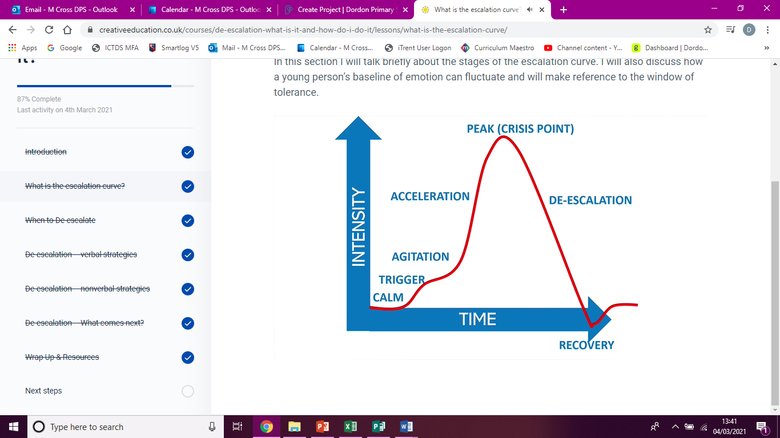
Our aim as a school is to employ strategies to avoid a person reaching their peak. We use a wide range of strategies to achieve this. This is dependent on the age of the child, circumstance, cognitive ability, needs of the children, etc. Interventions are tailor-made to the person involved.
See Appendix D for the range of strategies that could be employed by any adults in school
For anyone who dysregulates (reaches PEAK) frequently, positive handling plans are implemented that outline strategies that prove to be most successful for an individual and those to avoid. It also outlines how the child can best support themselves in the regulation of their emotions. Involvement of the child in this process is intrinsic to its success.

Restorative Practice
The process involved in this approach is ongoing and starts with the frequent interactions listed above. Elements of the building and maintaining relationships and the recognition and naming of feelings is woven into every aspect of the curriculum – both the explicit planned curriculum and what we refer to as the ‘hidden curriculum’ the ongoing reinforcement of the key principles through incidental opportunities. These are considered to be preventative and avoid relationships being harmed.
The responsive element of the approach happens when relationships have been impaired. Restorative conversations will take place to repair any harm and move forward in maintaining the relationship that has been established.

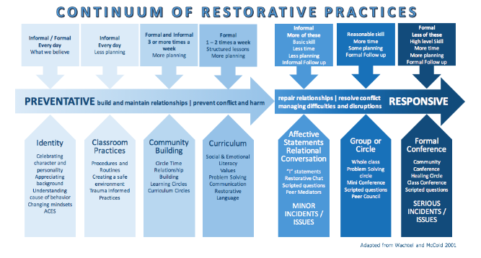
Restorative conversation
There are varying degrees of restorative conversation that can be deployed when an incident happens. The level of formality will depend on what has happened. It ranges from a quick prompt through to a structured conversation between all parties. Staff will use shared language and sentence prompts to support the conversations with children- Appendix E
Where it is felt a structured conversation is needed with an individual where a person hasn’t been directly affected, the following questions will provide the structure.
LISTEN- What has happened? What were you thinking?
LINK – How did you feel when this happened?
LEARN – What could you do next time?

Where a person has been directly affected by the actions of another, a conversation will take place together, by mutual consent, to explore the situation and repair the relationship. This will use 6 questions to structure the conversation with the harmer going first. The conversation will be facilitated by an adults and both parties get the opportunity to explore the situation.
Prior to this conversation, the harmer and the harmed will be spoken to separately to establish their willingness to participate in the process. See Appendix F.

The 6 questions to structure the conversation are as follows:-
- What happened?
- What were you thinking/ feeling?
- Who has been affected?
- What are you thinking/ feeling now?
- What needs to happen to put it right?
- Next time I could….
Prompts to support this conversation will be displayed in classrooms and key areas in school. All staff will have a copy to refer to – Appendix G.

Community
This approach will be used across school and for all stakeholders, not just the children. This means that restorative conversations may take place between adults and children, staff members in school and staff members and parents. Our aim with each of these conversations is to maintain the positive relationships on which we pride ourselves.
There are incidents that occur outside of school hours and premises that can impact on the wellbeing and participation of children in school. An example of this could be online incidents or incidents in the local area. It is at the school’s discretion as to whether they intervene in such incidents but where it is deemed essential – a restorative conversation will be facilitated by adults in school to attempt to find a resolution and maintain relationships.

Consequences
Our understanding of the term consequence is that it is a result or effect of an action undertaken by an individual. We believe that consequences should be logical and linked to the action. Therefore the consequence will be determined through the restorative conversation that takes place with those involved.
For example: A child who dysregulates and lashes out when they lost a game on the playground would be involved in a restorative conversation (including the harmed if appropriate and consent is given). A logical consequence here might be to have a graduated return to break times.
There may be occasions where the consequence of an action could be suspension from school on a fixed term basis. This indicates the seriousness of their actions and allows school the time to review practice and put in place the plans necessary to minimise the chances of this happening again. If this were to happen, the child would have this explained to them so that their sense of belonging is not harmed. School may also use internal exclusion where the child does not have access to their usual learning provision, adults and peers – including social times. During this time, they will continue to access the curriculum and also reflect on the incident that led to this.
Following a suspension, a reintegration meeting takes place with the child, parent and a member of SLT to discuss the incident and the way we are going to move forward. If a child is not ready to return to class, then SLT may make the decision to have an internal exclusion or a further suspension.
In some circumstances, the school may be left no choice other than to permanently exclude. This will be where there is a serious breach or persistent breaches of this policy; and where allowing the pupils to remain in school would seriously harm the education or welfare of the pupil or others such as staff or pupils in school.
All decisions to suspend or permanently exclude are made in line with the Community Academies Trust exclusion policy by the Executive Headteacher.

Legislation and Guidance
- Behaviour in Schools (February 2024)
- The Equality Act 2010
- Supporting pupils with medical conditions
- SEND Code of Practice
- The Children’s Act

Training
Our staff are provided with training on our school’s approach to managing behaviour as part of their induction process. This will focus on the importance of building relationships and the restorative practices in school.
Behaviour management will also form part of continuing professional development seeking external support where appropriate.
Many members of staff have been trained in TEAM Teach techniques, which also forms part of the cycle of continuing professional development.

Monitoring
This policy will be reviewed by the Executive Headteacher every year in consultation with the staff team. At each review, the policy will be approved by the School Standards Committee.

Links to other policies
- Staff code of conduct
- Child protection
- Positive Handling
- Exclusions
- Anti-bullying
APPENDIX A – Examples of behaviour that does not meet school expectations
All incidents that fall into this category are recorded on CPOMS/ Arbor and monitored by SLT.
- Acts of intentional violence towards adults or children
- Leaving school site without consent
- Drug related incidents
- Dangerous items being brought into school
- Intentional damage to property and belongings
- Stealing
- Bullying other children
- Racism or homophobic incidents
- Swearing/ derogatory language
- Deliberate, persistent and malicious lying
- Play-fighting and rough play
- Refusal to follow instructions/ non-compliance

APPENDIX B - Rewards
At Dordon, we have many rewards that can be given to the children.
Verbal praise is given often in recognition of good work and meeting the expectations of RESPECT in many different ways.
GEMS are given using the Class Dojo system. GEMS are awarded to children and are collected across a half term. We award prizes for children with the most GEMS and also the children who received the most GEMS for respect.
G – Growth Mindset
E- Effort
M- Manners
S – Success
Visits to the Executive Headteacher and Associate Headteacher are encouraged to share positive contributions to school whether these are academic or to the wider school community.
Email home is sent on Friday to a child in each class who has shone for any reason across the week.
Celebration assembly happens once a week and celebrates success inside and outside of school.

APPENDIX C – Zones of Regulation
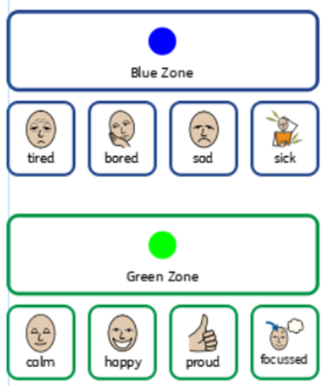
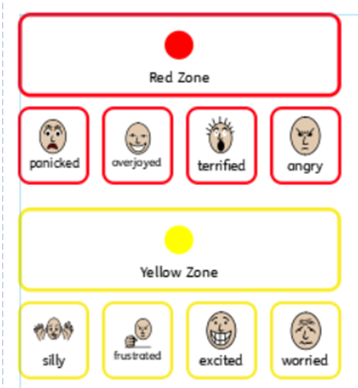

APPENDIX D - De-escalation Strategies
Verbal Strategies
Talking to children can help them to start calm. However some children, especially those on the ASD spectrum may not be able to tolerate speaking as they may be experiencing sensory overload. They may find you will need to be quiet until they start to calm down and can tolerate talking again. This is hard.
For the majority, the voice is a powerful tool. For children you don’t know well, watch when you are talking to them and see if it is working IF NOT then stop.
Have a chat when the child is calm and say: ‘During the time we were together I said ________, did you find that helpful or was it annoying?’ Explore which phrases, if any, helped and share the information with other colleagues.

TOP TIPS
- Keep your voice low and slow- keep the volume low, keep the pitch low and speak slowly. Keep any instructions short.

- Rhythm and repetition – this actively calms the brain. Repeating a phrase such as: ‘It’s ok.’ ‘I’m here with you.’ ‘You’re safe.’ Or ‘Take a deep breath in, and breathe out.’ Share good phrases with other adults who work with that child.

- Focus on feelings – how the young person feels is at the heart of what is happening for them but some may struggle to verbalise how they feel. Use phrases like: ‘I can see you are feeling sad.’ ‘This must be upsetting for you.’ Or if you are unsure how they are feeling and you don’t want to get it wrong say ‘I wonder if you might be feeling…..’ or ‘It seems like you are feeling …… am I right?’
Verbalising when they can’t shows you understand what is happening for them – it may not just calm them down but it could build a connection between you and the child.
Validating their feelings is not the same as validating their actions.

- Be empathic and non-judgmental – Feelings for that child are absolutely real for them whether you feel they are justified or not. Acknowledge and accept them and show you understand. Avoid reasoning with the child until later when they are calm. Doing it too soon could lead to escalation.

- Distract and Divert – Distraction helps a young person if they are continuously talking about what is bothering them. It often works best with younger children.

  - Distract by changing the subject
  - Start playing slowly with a toy or object near by
  - Get them to look out of the window and count something e.g. green things.

- Repeat back – Listen to what the child is saying (if they are talking) and repeat it back to them. Summarise for them what they have said. ‘I can hear you are telling me….’

- Choices – It is important to be clear about what is negotiable and what isn’t. Having a choice will decrease the anxiety for a child. When giving choices:

  - Speak slowly
  - Offer the positive one where you think it will be most effective (based on what you know about the child)
  - Limit the number of choices
If there are lots of people around when a child is distressed, you could ask, ‘Do you want to stay here with me or come to my room?’
When they have recovered enough, ‘Would you like to go back to class now or do you need 5 more minutes?’ Either way they will be back in class but they will feel like they are in control.

Non-Verbal Strategies
The more that a child is in distress, the less they will hear your voice. When faced with a child in distress, think animal. Think about the things you would do if you encountered and angry bear or a wounded, shaking dog who doesn’t want anyone to touch them. This will help you in the choices you make.

- Keep your emotional brain in check (manage your chimp)- stay calm and rational. You cannot control the person but how you respond to them will be a factor in whether the situation escalates or diffuses. Think positive thoughts and remain calm.
When a young person has least control, that is when we need to be the most in control of ourselves.

- Environment – Get the child away from everyone if you can. If appropriate, lower the sensory stimulation (close blinds, turn off the lights, etc)

- Space – Think position, posture and proximity
If you need to enter their personal space to keep a child safe, then explain what you are doing. Again think animal.
- Approach slowly
- Stay where they can see you
- Don’t approach from behind
- Be mindful of gestures and facial expressions. Keep them neutral.
- Be at their level. This reduces the threat level and feeling of intimidation.

- Silence is golden – Allowing time and silence will bring calm. Don’t feel pressured to move things on.

- Breathing control – Deeper, slower breaths will help the calming process. If we as adults do it, model it, then it helps us to remain calm but eventually it will allow the child to match our breathing pattern.

There is no sure and steadfast method for de-escalation. What works one day may not work the next but these strategies may help you have a wider repertoire of tools available to support the process.

A mixture of these tools may help us to be more successful in de-escalating situations before crisis or supporting the recovery better. What is key is the communication with adults about what is working and knowing the children. Being aware of triggers and signs of agitation and anxiety. If you have this information make sure it is shared with all the relevant adults who work with the child.

Look after you – dealing with distressed behaviours can be exhausting, emotionally draining and personally challenging. There is no shame in recognising that you are not emotionally secure at a given time and therefore not the person to be dealing with a child in distress. We are all human and have ebbs and flows in our emotional and mental health and wellbeing.
It is also important that after you have been dealing with a child in distress that you take time for you to reflect on what has happened and check that you are feeling ok. Talking to people is important.

APPENDIX E – Language Prompts
I see that your shoulders are hunched and think you might be upset?
I see two children who both want the same toy.
I wonder if you’re feeling…..because….
I can see how you might feel…..because….
Maybe it’s not the right time now, I will catch up with you later.
I hear you need space. I’ll be over here when you need me.
Do you think you might be disappointed?
It’s ok to feel…
I understand you are…. But I can’t let you…I need you to be safe.
Remember when we discussed when you feel…..we can…(insert chosen strategies here)
I feel…..sometimes too; let’s figure this out together.
How can I help you now?
Tell me about what happened….
What could you do next time?
Help me understand how….
I need you to…..thank

Appendix F – Restorative Process
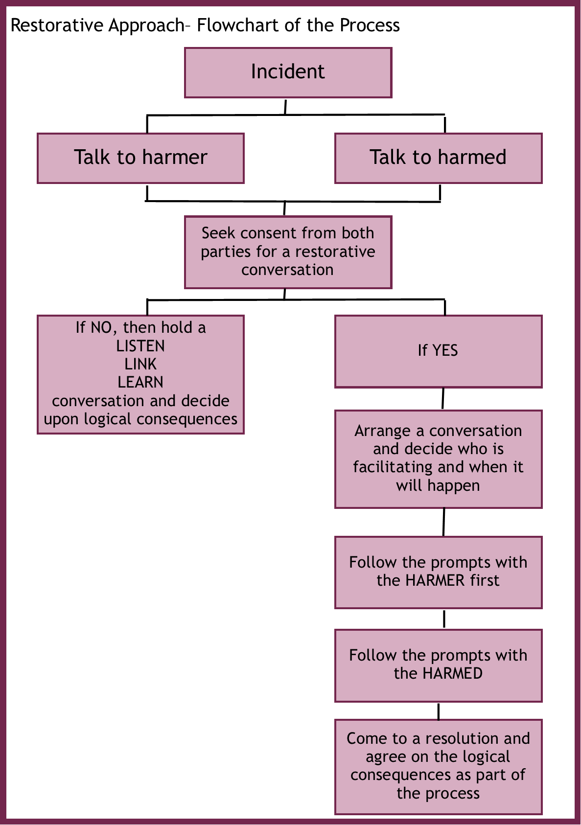
APPENDIX G – Prompt Cards for Restorative Conversation
